Whois UseCase Diagram

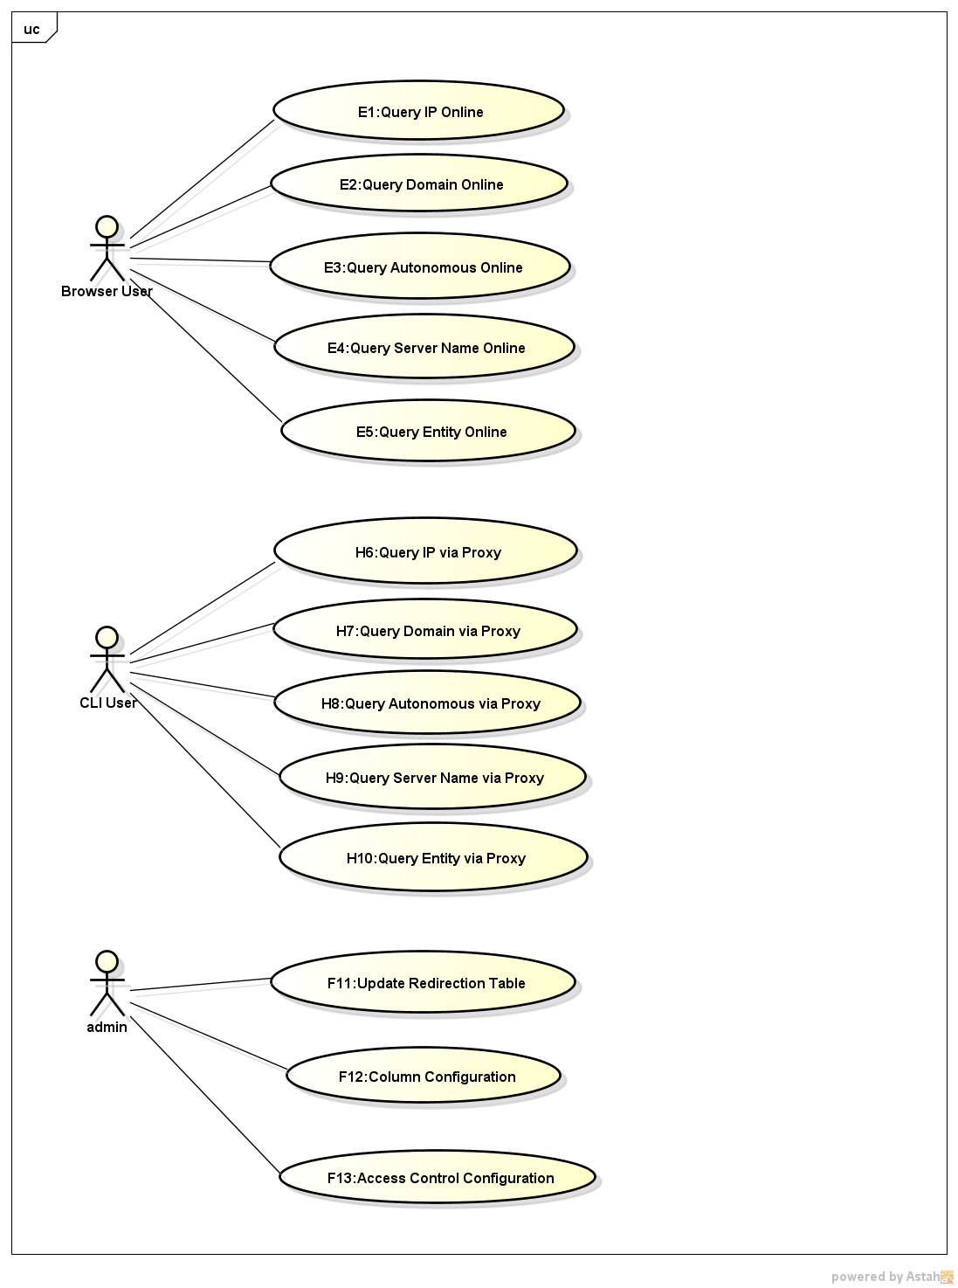

The use case diagram describes the project to achieve the function。